GIANT UPS

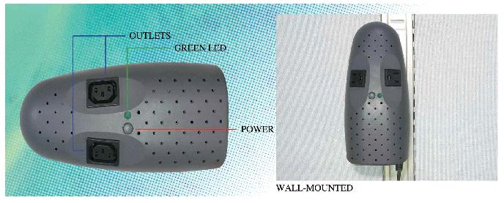

Specification
- SELF TEST:
Self test each time switched on.
When UPS is turned on, it makes self-test to provide a reliable operation and prevent any damage caused.
BATTERY PROTECTION:
Auto self-test and discharge protection.
- DC START CAPABILITY:
The UPS can be activated without utility power.
- UPS POWER SUPPLIED OUTLETS:
Line-Interactive UPS+AVR
Allows 75% to 125% input voltage range-best protection for computer equipment.
With AVR function (boost & buck), UPS provides a stable power to the loads as the input voltage fluctuates.
- ELECTRICAL PROTECTION:
Automatic cut off on short circuit and Over Load.
- AUDIBLE ALARM:
Battery Back-up: slow beeping (10 seconds) Battery Low and Overload or AC Overload: Rapid beeping (1 Second)

- CPU MICRO PROCESS CONTROL, USE WITH STABILITY.

- GREEN FUNCTION:
If the battery is discharging under no load, will shut down automatically to keep the span life of battery

UPS MODEL |  | GT-500
Capacity |  | 500VA
Input | Voltage | 110V(80-140V) / 220V(160-280V)
Input | Frequency | 50Hz±5% / 60Hz±5%
Output | Voltage  (Battery Back-up) | 110V±10% / 220V±10%
Output | Frequency  (Battery Back-up) | 50Hz±0.5% / 60Hz±0.5%
Output | Regulation Wave | Stepped approximation to Sine wave
Battery | Type | Sealed maintenance free lead-acid battery
Battery | Recharge Time | < 4 hours to 90% of full capacity
Battery | Back-up Time | 5 - 10 Min
Battery | Numbers | 12V 4.5AH x 1
Approval | Safety | CE / CNS
Environment | Operating Temperature | 0° ~ 35°C (32° ~ 95°F)
Environment | Relative Humidity | 0 ~ 95% Non-Condensing
Surge Energy Rating |  | 240 Joules
Normal Mode Noise |  | Full Time EMI/RFI Filtering
Phone Jack |  | For Modem/Fax/Network
Protection |  | Short & Overload;  Battery Low Cut off
Outlets |  | IEC or USA
Physical | Weight (Kg) | 4 kgs
Physical | Dimension  W x D x H (mm) | 107 x 230 x 119
Installation method |  | Wall mounted, or flat-put

